Fact File
Set 4. Student 2. ETERI TUTBERIDZE
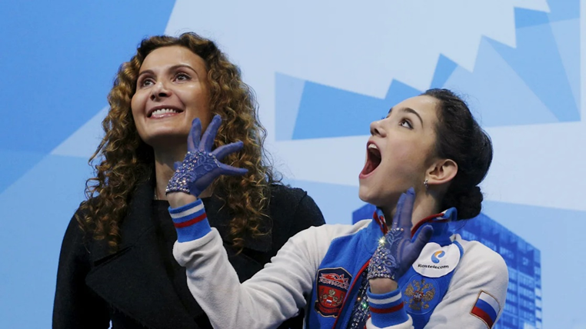
Eteri Tutberidze is a Georgian-Russian figure skating coach who works mainly with female single skaters. She is head coach at the Sambo 70 skating club in Moscow.

Biography

Eteri Georgievna Tutberidze was born 24 February 1974 in Moscow. The youngest of five children, she is half-Georgian, a quarter Russian, and a quarter Armenian. Her mother was a senior engineer at the Ministry of Agricultural Construction and her father worked at the Likhachev plant's foundry and as a taxi driver.
Tutberidze studied at the Academy of Physical Education and received a degree in choreography from the Institute of Contemporary Art. She worked in ice shows in the US for six years in the 1990s. She is the mother of figure skater Diana Davis. Diana had been coached by her mother as a single skater until 2016 when, at the insistence of her mother, she opted for ice dance.

Sporting career

Tutberidze began skating at the age of four and a half. After sustaining a spinal fracture and growing 22 cm, she switched from singles to ice dancing. She was coached by Lidia Kabanova for two years and then joined Elena Tchaikovskaya, who paired her with Vyacheslav Chichekin. Tutberidze then switched to Gennady Akkerman, her coach for the next three years. She skated with Alexei Kiliakov until he emigrated to the United States.
During the 1991–1992 season, Tutberidze trained under Tatiana Tarasova before deciding to perform in ice shows. Appearing as an adagio pair skater with Nikolai Apter, she toured with Ice Capades for several years. She worked in ice shows in the US for six years in the 1990s, including the show in Oklahoma at the time of the 1995 Oklahoma City bombing, for which she received compensation as a survivor. She decided to return to Russia and start from scratch.

Coaching career

Tutberidze started her career as a skating coach in San Antonio, Texas. After returning to Russia, she coached at several Moscow rinks, including a hockey rink Serebrianyi, where ice time was limited for figure skaters. She then moved to Sambo 70, a children's and youth sports school in Moscow. She is now head coach at this skating club. She has coached several Russian skaters to success in international competitions, including Olympic and World champion Anna Shcherbakova, Olympic silver medalist Alexandra Trusova, Olympic Team champion Kamila Valieva, European Champion Alena Kostornaia, Olympic and World champion Alina Zagitova, two-time World champion and two-time Olympic silver medalist Evgenia Medvedeva, and Olympic Team champion Yulia Lipnitskaya.
The aphorism of Russian generalissimus Alexander Suvorov “Hard training makes battles easy” perfectly illustrates the rules installed by Tutberidze on the ‘Khrustalny’ rink: be two heads above your opponent and you will never get unfairly judged by the jury.

Interesting facts

The best coach at the ISU (International Skating Union) in 2020 and the woman behind a number of champion titles for her charges, Eteri Tutberidze is an indomitable fighter. She had to quit the sport because of an injury, but she came back triumphantly as a coach.

A good half of her students’ iconic programmes are her personal revelations. Medvedeva’s ‘Hear/Don’t Hear’ programme is a story about Eteri’s daughter Diana Davis, who lost her hearing as a result of side-effects from taking antibiotics.
.

